

**IBM DATA ANALYTICS ASSIGNMENT - 3**

**Name: Shriraj Patil**

**Mail id: Shriraj.21bce7361@vitapstudent.ac.in**

**Lecturer Name: Indra Sir**

**Now for the assignment 3 we are using the Tableau Software**

**While let us use the MY SQL for the connectivity for that we have create a data base named as (super data)**

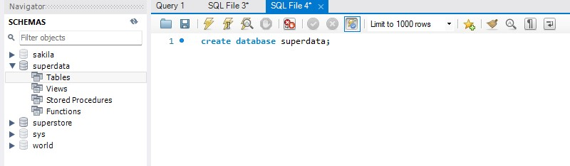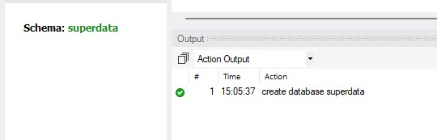

**After creating the data now we have to insert the give data set into it**

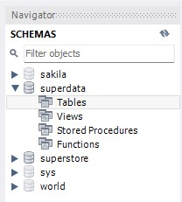

**Now we have to insert the data in the tables in the table data import wizard**

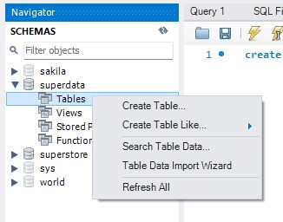

**Now insert the data from your computer and next**

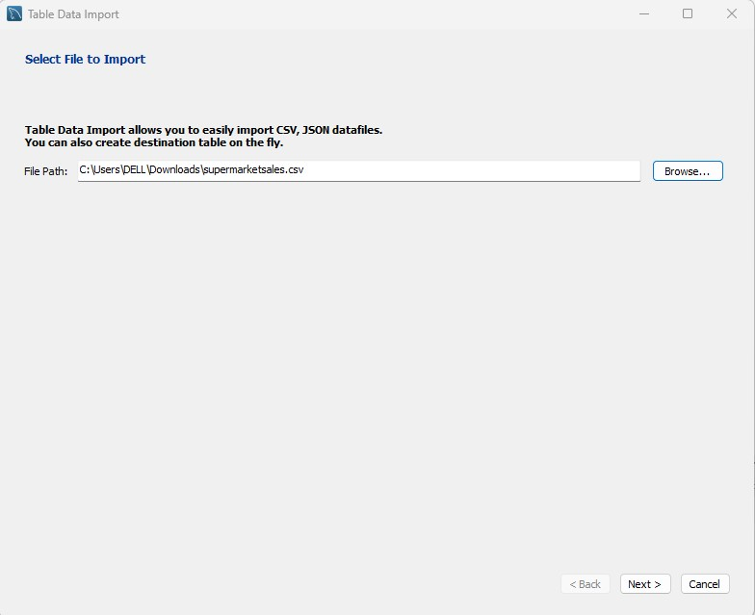

**It will come after inserting the data**

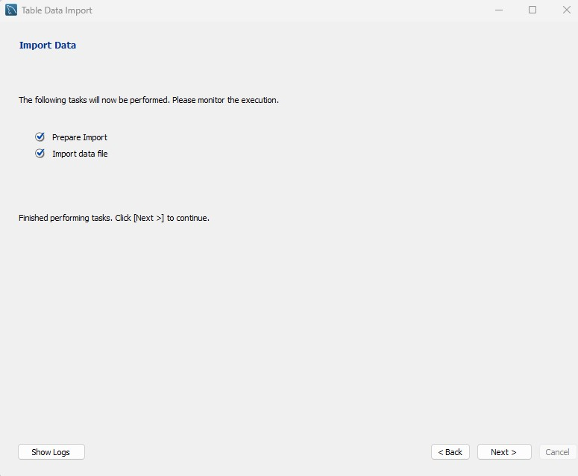

**Our table was inserted**

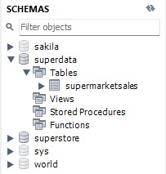

**Now connect the tableau with the MY SQL server**

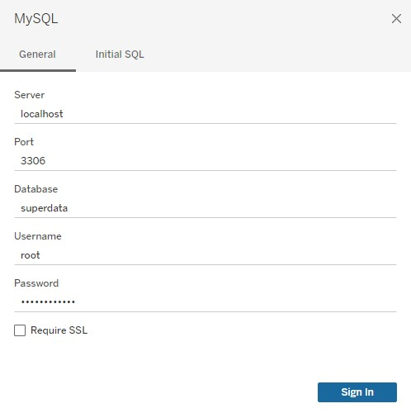

**After filling these details sign in and our tableau worksheet will ready**

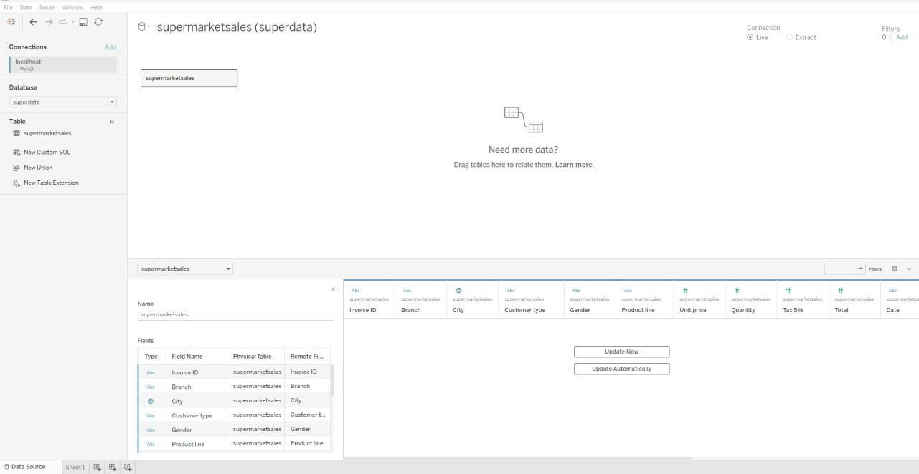

**Now let create the visualizations by using this tableau software**

1. **Bar Chart:**

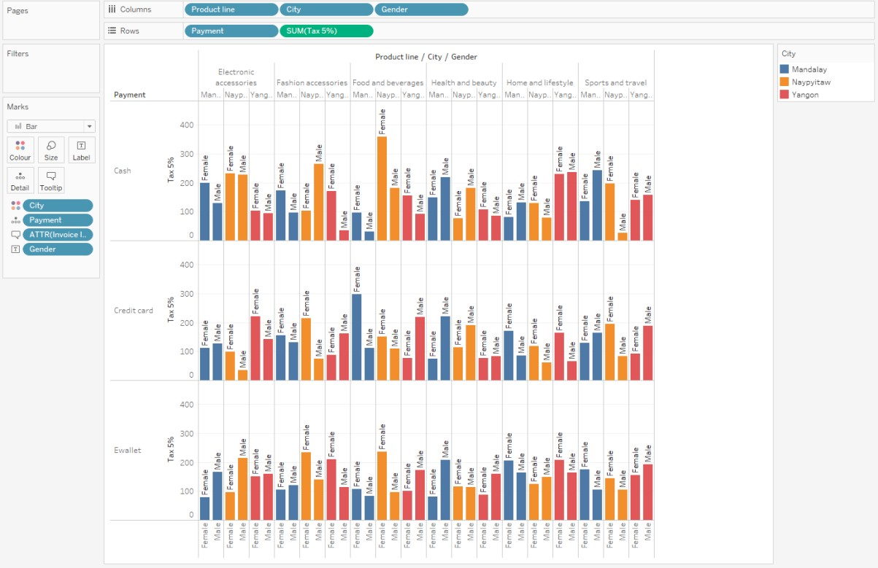

1. **Pie Chart:**

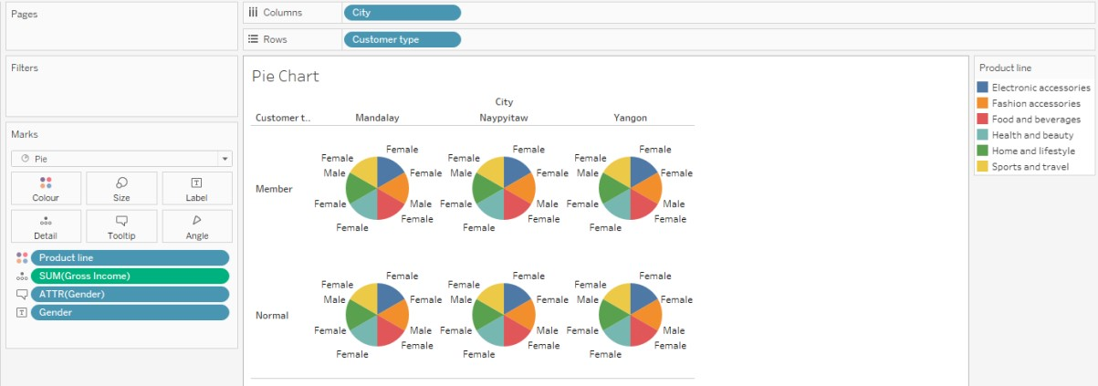

1. **Stacked bar chart:**

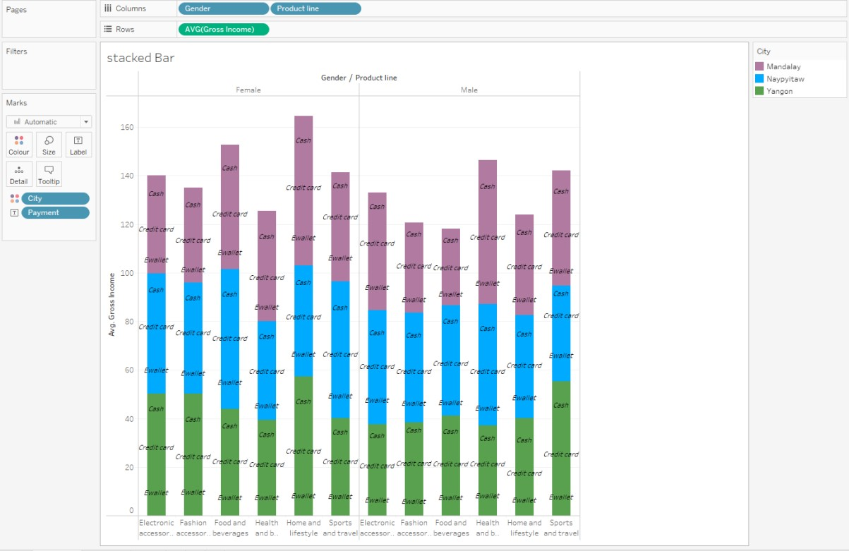

1. **Square:**

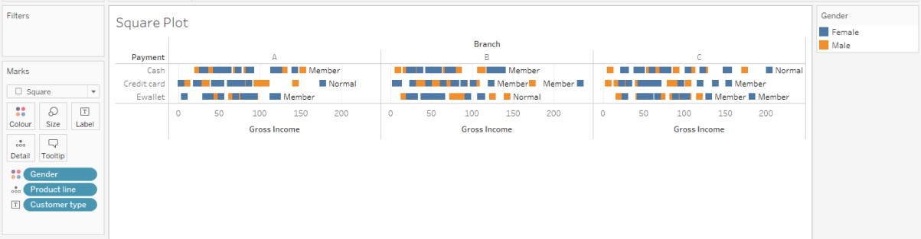

1. **Line Chart:**

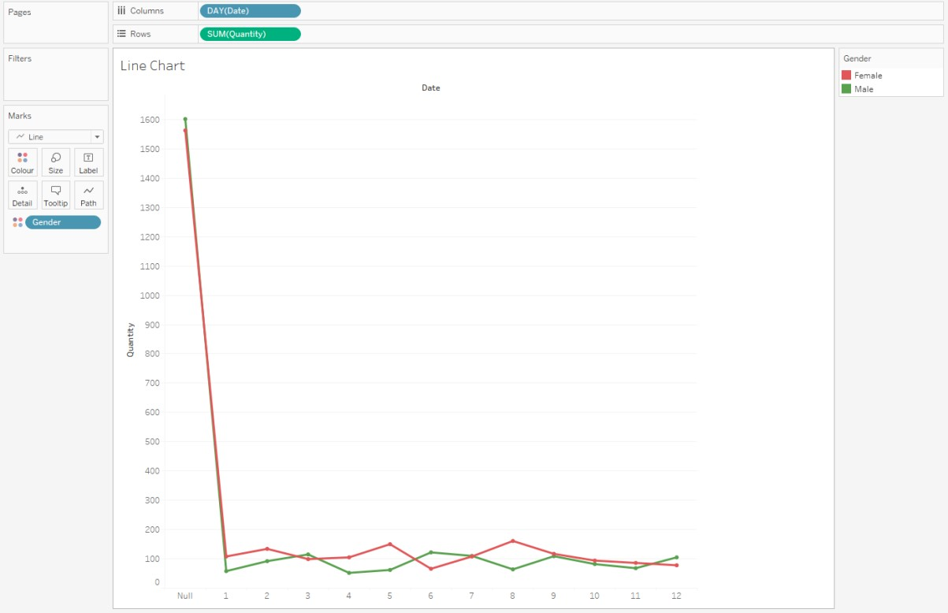

1. **Tree Map:**

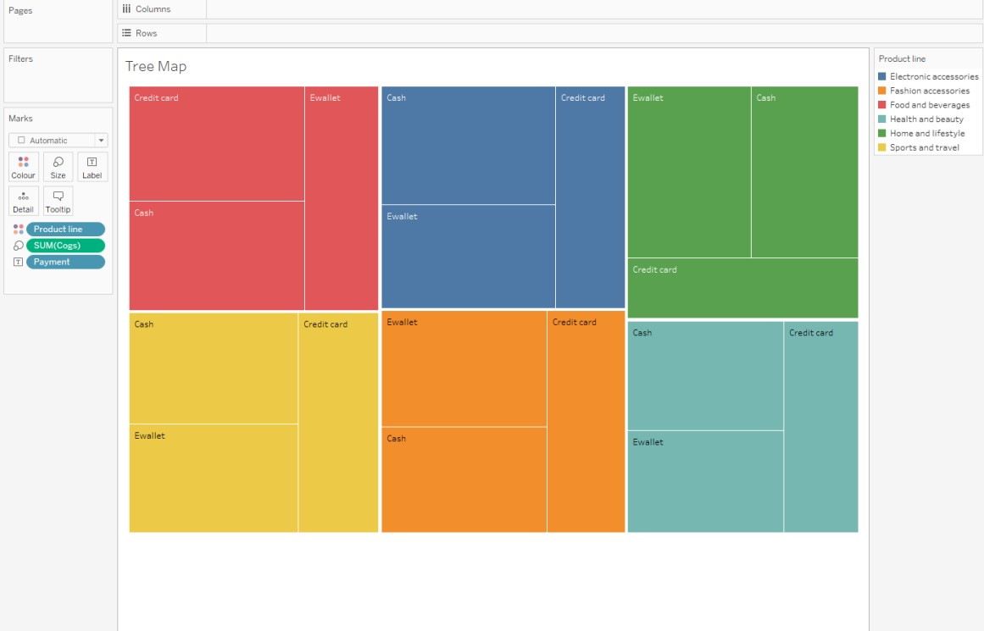

1. **Circle Chart:**

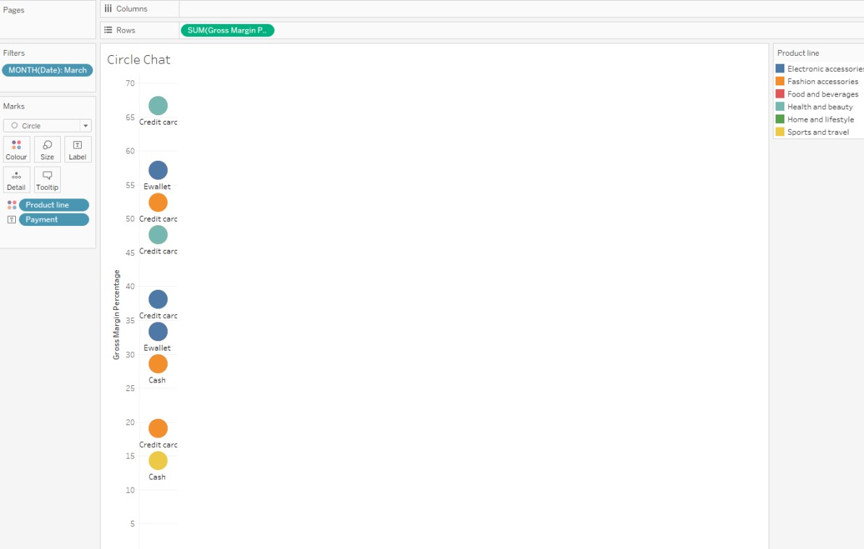

1. **Gantt Chart:**

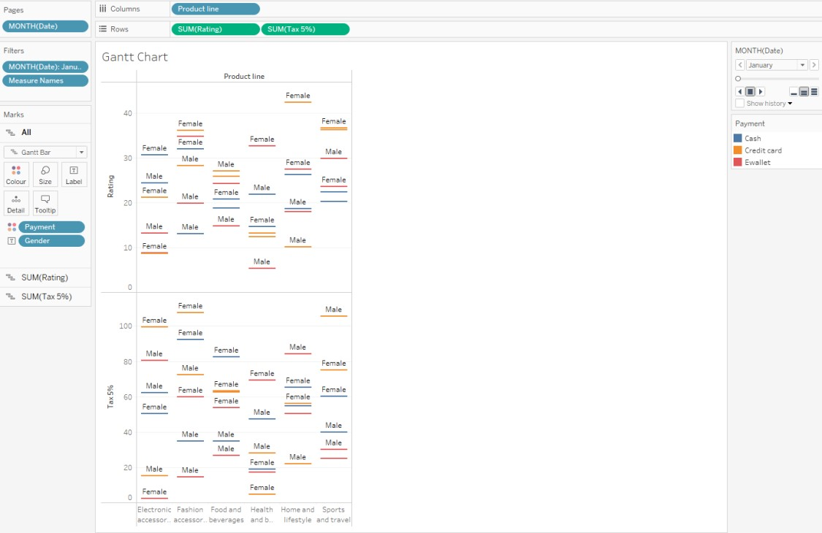

1. **Area Plot:**

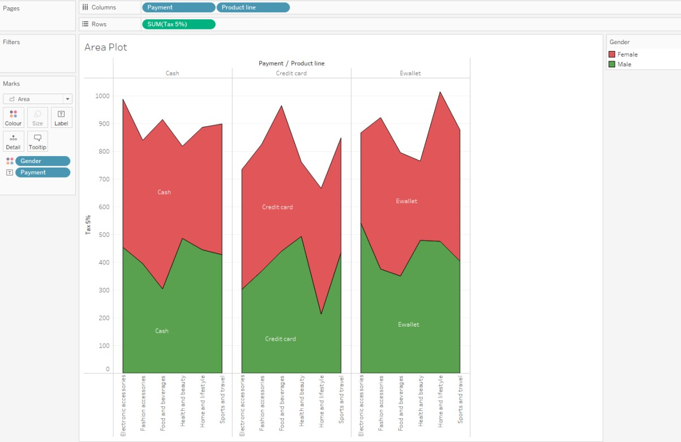

1. **Bubble Chart:**



